**[Music Player app]**



## DHANEKULA INSTITUTE OF ENGINEERING & TECHNOLOGY

Accredited by NBA (CE, EEE, ME, ECE, CSE) and NAAC

Approved by AICTE, Affiliated to JNTU, Kakinada, An ISO 9001 Certified Institute

**Documentation by :**

(CSE(AI & ML)-A)

**Name of the organization :** IIDT Blackbucks

**Name of the domain :** Full Stack Development

**Duration :** 45 Days

**DHANEKULA INSTITUTE OF ENGINEERING AND TECHNOLOGY**

Ganguru, Vijayawada – 521139

Affiliated to JNTUK, Kakinada & Approved By AICTE, New Delhi Certified by ISO 9001-2015, Accredited By NBA Department of Computer Science & Engineering **CERTIFICATE**



This is to certify that the Summer Internship project work entitled **“Music App using HTML,CSS and Javascript”** is a bonafide record of internship work done by – Ch. Sri Abhiram **(228T1A4225)** award of Summer Internship in **Computer Science and Engineering by Jawaharlal Nehru Technological University, Kakinada during the academic year 2024-2025.**

## Head of Department

**Dr.Ch.Suresh Babu**

**Professor, HOD CSE(AI And ML) EXTERNAL EXAMINER**

**CERTIFICATE FOR COMPLETION**

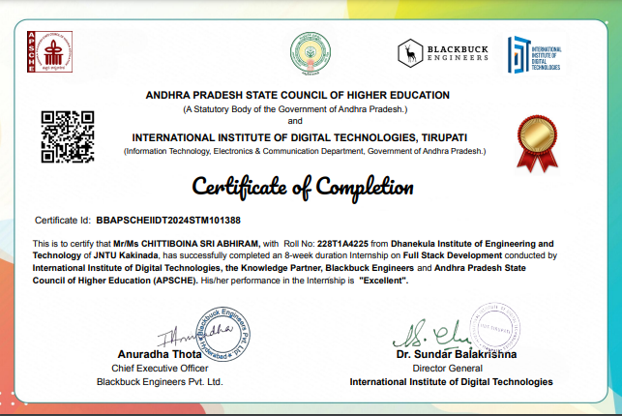

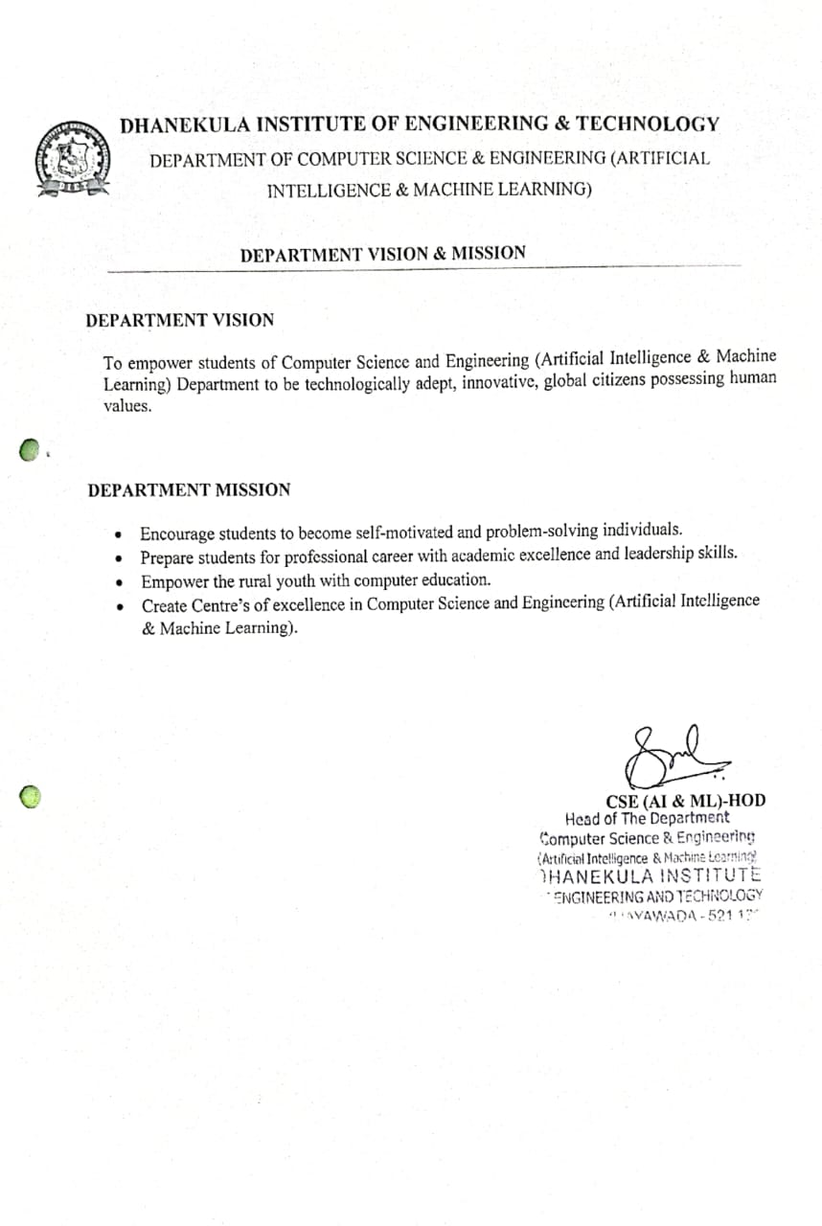

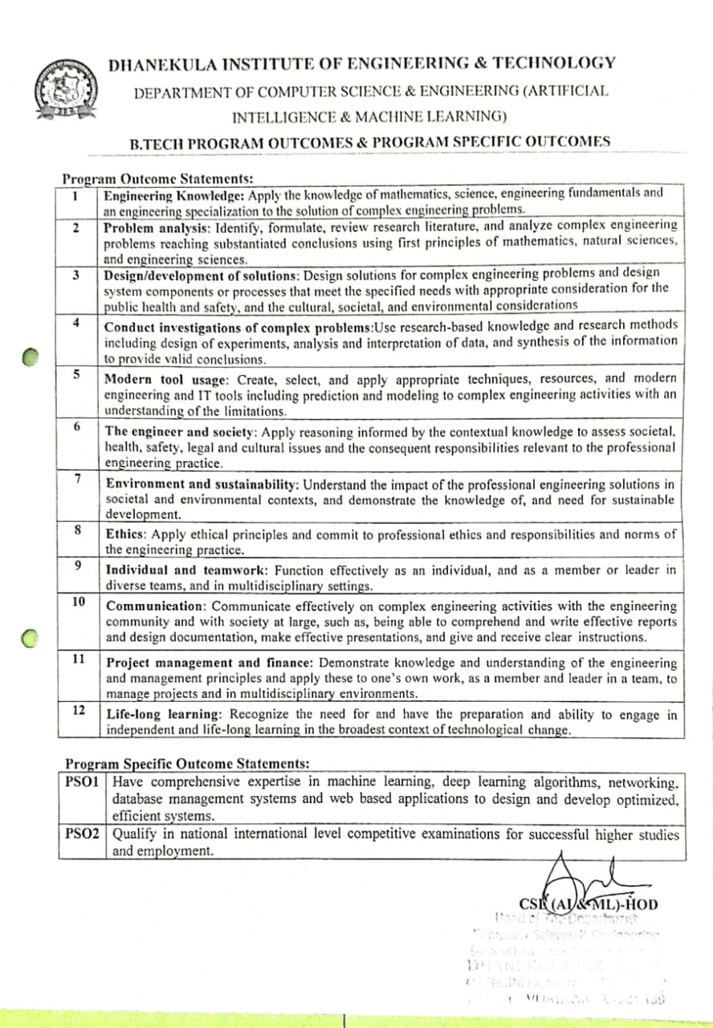

Internship Mappings

|  |  |  |  |  |  |  |  |  |  |  |  |  |  |  |
| --- | --- | --- | --- | --- | --- | --- | --- | --- | --- | --- | --- | --- | --- | --- |
| Project Title | P  O  1 | P  O  2 | P  O  3 | P  O  4 | P  O  5 | P  O  6 | P  O  7 | P  O  8 | P  O  9 | P  O  10 | P  O  11 | P  O  12 | P  S  O  1 | P  S  O  2 |
| Enhancing medical diagnosis with machine learning |  |  |  |  |  |  |  |  |  |  |  |  |  |  |

|  |  |
| --- | --- |
| Mapping Level | Mapping Description |
| 1 | Low Level Mapping with PO & PSO |
| 2 | Moderate Mapping with PO & PSO |
| 3 | High Level Mapping with PO & PSO |

Contents

1. Internship carried out Company/Organization Details

2. Internship Log.

3. Domain area of the Internship.

4. Project report

1.Internship carried out Company/Organization Details

**NAME OF THE ORGANIZATION: BLACKBUCK ENGINEERS Pvt Ltd**

**Blackbuck Engineers is started in 2013 with the aim of creating a great ecosystem of academia, research, industry, and individuals. Blackbucks is a premier partner to Govt of AP & Telangana, the International Institute of Digital Technologies, IITs and JNTUs. Blackbuck delivers the TAPTAP platform to transform the journey of students towards their dream goals while helping HRs high right students.**

**Till now, Blackbuck conducted a faculty development program for more than 7600+ faculties across India and also helping 1,22,000+ students across India instream lining their career paths.**

**APSCHE - IIDT - Blackbucks Internships**

**International Institute of Digital Technologies (IIDT) Tirupati is an initiative of the Government of Andhra Pradesh in order to enhance the skills of students in emerging technologies.**

**About Blackbucks:**

**Blackbuck Engineers is the knowledge partner of IIDT, and various other prestigious organizations.**

**Blackbuck is the largest network of centers of excellence in emerging technologies.**

**Internship Streams**

1. **AI/ML/DS**
2. **CYBER SECURITY/ ETHICAL HACKING**
3. **FULL-STACK DEVELOPMENT**
4. **CHATGPT/ GENERATIVE AI**
5. **VLSI**
6. **EMBEDDED SYSTEMS &IOT**
7. **BUSINESS ANALYTICS**
8. **CRM TOOL & DIGITAL MARKETING**
9. **PROJECT MANAGEMENT**
10. **LOW CODE NO CODE**

**Internship Log**

**WEEKLY REPORT**

**SESSION 1:** 27 May2024

**NAME OF THE TOPIC:** Full Stack Fundamentals

This interactive session helps us in learning about full stack development. How it is used and Where it is used and about front-end and back-end technologies and about framework .web design and web development differences between the web design And web development.

**Topics Covered :**

1.What is Web design 2.what is web development

3,Differnces between web design and web development 4.Whai is full stack development

1. What is front-end and front-end technologies 6.What is back-end and back-end technologies 7.What is framework

**Key points:**

*Website is a collection of webpages and related content that is identified by a common domain name and published on at least one web server

*developments are three different terms front-end development, back-end development and full stack development

*Which we are working on graphic side like UI UX ,designing the user experience , which font which images to use on the page, deciding structure of the page is known as web design.

*Writing the code to implement the design is known as web development. Once the design is completed the design is ready then it comes to the development team to implement the design.

*The implementation can be done in two ways one is front-end development and another one is back-end development

*A web designer is a graphic artist who is responsible for designing the layout, usability, and visual appearance of a website. A web developer is someone who is responsible for converting the web design into a functional website, using coding languages such as html, javascript, php, etc.

*frond-end is everything that is visible to the user.

*back-end is everything that is user cannot see. The term full stack is basically a development or a development who can write entire application on their own. website is static that means it is an representation.

**Session-2 :** 3 June 2024

## NAME OF TOPIC:

The second session is about HTML. What is html how it is used. Html Structure, Tags etc.

Topics Covered:

1.Introduction of html

2.structures of html

3.Tags

4.heading tags

5.body tag

6.meta tags

7.Body Contents

8.paragtaph tag

9.break tag

10.italic tag

11.underline tag

12.semantic tags

**KEY POINTS:**

HTML stands for hyper text markup language.

* HTML is a standard language which is used to create web pages. It is like an skeleton of a web page. Providing basic structure and elements that makeup the content and layout.
* HTML allows to add content to the web page.
* Whenever we need to change headings, style and title then that are done by html.
* Basic structure of html is html tags and html headings.
* We need to html file with extensions then only web page is indicated and directly recognizes.
* Index is a setup, The browser always looks for an index. If we don’t have index.html then it wii throw an error.
* In html we had two Main tags head tag & body tag.
* Head tag is a container for data about data and it is placed between html tag and body tag.
* The head tag is an HTML element used to define the head section of an document.

**Session -3 :** 4 June 2024

**NAME OF THE TOPIC:** Creating a single page web apps with React.js

The Third Session is about creating a single page web apps with React.js In this session we learnt Detailed explanation about web site and web apps. Node.js installation and how to run node.js in vs code,React.js installation and explanation and a bout files and folders in react and explained About file structure and project.

**Topics Covered:**

1.Web site and web app Detailed explanation.

2.Node.js installation.

3.Running Node.js in VS code.

4.React installation and explanation.

5.File structure and Project explanation.

6.React files and folders explanation.

**Key points:**

* Website is known as Static which means ,The user is not contributing to the data. I’ts read only
* Web application is dynamic ,That the web application can take user input can take some data from the user is able to add on to your data ex: Linkedin , facebook, youtube etc.,
* React gives us the ability to build such web apps where we have multiple independent components that are put together on a single screen.
* Single html page is used in the entire project and everything will be managed by javascript.
* The reason why react apps are called single page application is because there is only one html file is used for the entire project.
* Node.js it allows us to run Javascript outside of the browser.
* Node.js is a tool that helps us to create react apps.
* To create a new react app we have to write terminal command using node.js
* To run the node in vs code the command is npx create react app and name of the application.
* The command is going to create a brand new folder within which the react app will be created so there are going to be a lot of default files and folders that get created.
* React is a library for web UI and web interfaces, so basically react.js just gives us a lot tools which are called components to create different types front-end elements.
* In simple term what will react do is it will give us tool kit away of creating UI components or UI elements.
* CD Command purpose is to change the directory.
* Once node.js is installed then you have to run a command for installing the create react app command that command is npm install -g create-tract-app then create npx space create react app and name of the application.
* The name of the app can be only in lower case.
* Npx means node package execute.
* Npm means Node package manager.
* Once the application is created and then we can see some folders and files
* Package.json is a file which keeps track of the entire project it is a setup that work on the entire project if it is not there the project will not work.
* Package-lock-json is an supporting file for a package.json we should not make any changes in this file. It is expanding that everything mentioned in the package .json
* Node-modules folder keeps the track of all the dependency installations.

**Session -4 :** 11th June 2024

**Name of the Topic:** DOM(Document object model)

The fourth session is about Detailed explanation about DOM(Document object model).Manipulating html withJS. Manipulating CSS with JS , Data types of JS And variables of JS Connecting CSS and Java script in html page.

## Topics covered:

1.DOM

2.Manipulating html with js.

3.Manipulating css with js

4.JS fundamentals

5.JS Data types

6.JS Variables

**Key points:**

* DOM Means document object model is a programming interface for web documents. It represents the page so that programs can change the document structure, style, and content. The DOM represents the document as nodes and objects:t hat way , programming languages can interact with the page.
* Connecting html with css where we can write a tag which is link tag that is this file will tells that we are trying to connect css with html after that it will change the styles in html page.
* Connecting html with Java script we can use script tag that is .
* When we are working with the css styles need not to be shown to the user that is why we write css code in head tag.
* Script always sets at the end of the body that’s why we always keep script at the end why we are keeping script at of the body because we need to set all the content the user don’t need to trigger at the moment so,we keep script at the end of the body and user can able to visit the functionalities.
* Data types of java script which is basically all the types of data java script supports.
* The data types are Number, String, Boolean, Object.
* Number data type covers all the type of numbers which means positive number, negative number, decimal , number, integer like that.
* String data type includes everything text related either it is single character or word or paragraph as long it is in text format , special characters numbers also when they are in text format.
* Boolean data type It contains only two values one is true and another one is false.
* Object data type where we can have all collection of data. There are multiple values for object. • We can create a multiple values in single object.
  + In variables we have three types that are var, let, cons

**Session -5 :** 17th June 2024

**Name of the Topic:** Combining HTML,CSS,Js

The fifth session is about making a to do list and combining html, css, javascript. How to make forms and eventhandling, and understanding about css.

## Topics covered:

1. Event handling 2.Java script 3.CSS

## Key points:

* + To create form field we use form tag and then we have several input types like text ,date , range .
  + Place holder is the dummy text or the container text that shows up
  + To read the data we have id.
  + To change the value we have value attribute.
  + Prevent default basically indicates that we don’t want to perform the default action.
  + The call() method is a predefined Javascript method. It can be used to call a method with an oewner objecjt as an argument.
  + With javascript to change the background color when the arrow over the heading we can write on mouseoverthe function should be change . and connect the event.
  + Target is used to change the target.
  + To display the screen we are using tasklisit.appendChild
  + Whatever we do in javascript is temporary , which means it will only stay until we refresh the page or reload the page.
  + In CSS we have 4 selectors ID selector, class selector, element selector, and the global selector or universal selector.
  + Global selector means everything on the page will be affected by it

**Session -6** : 19 June 2024

**Name of the Topic:** API & JSON

The Sixth session is about API & JSON . What is API, What is API is used for, API examples. What is JSON, what is JSON used for.

## Topics covered:

1.Event handling 2.Java script 3.CSS

## Key points:

* + API stands for Application Programming Interface, the word application refers to any software with a distinct function. Interface can be thought of as a contract of service between two applications. • API allowed developers to access certain features or data from another application or service.
  + API is like a messenger that helps different apps work together seamlessly. API’s are used in a wide range of applications, from social media platforms to weather apps.
  + API is language independent and technologically independent.
  + It is an interaction medium for an two different web applications.
  + The role of the API is enable two software components to communicate with each other using a set of definitions and protocols.
  + JSON Stands for JavaScript Object Notation. This is special data format. It is commonly used for transmitting data in web applications.
  + Ex: Sending some data from the sever to the client, so it can be displayed on a web page.
  + JSON is commonly used for data storage and transfer.
  + JSON is a popular choice for applications that benefit from a simple and easy-to-use data format.
  + The JSON data that we have is independent of the programming language.
  + To connect API we can use HTTP requests to the API endpoints using libraries like fetch.
  + The map function is going to go through at everything in the array.
  + Ex: Sending some data from the sever to the client, so it can be displayed on a web page.
  + JSON is commonly used for data storage and transfer.
  + JSON is a popular choice for applications that benefit from a simple and easy-to-use data format.
  + The JSON data that we have is independent of the programming language.
  + To connect API we can use HTTP requests to the API endpoints using libraries like fetch.
  + The map function is going to go through at everything in the array

**Session -7 :** 19 June 2024

**Name of the Topic**: Fundamentals of Python

The Seventh Session is about **Fundamentals of python**, Python definition, python variables, keywords,identifiers, Data types, functions, Operators.

## Topics covered:

1.Python Definition 2.Variables 3.Keywords

4.Data types 5.Identifiers 6.Functions 7.Operators **Key points:**

* Python is an high level open source interpreted scripting language, python is an dynamic typed language, python supports functional programming and object oriented programming approaches for solving programming problems.
* Python is a case sensitive language.
* Python is easy to understand and learn.
* Keywords are reserved words which are defined for doing specific tasks.
* True, None, False are in title case and remaining keywords will be in lowercase.
* We can’t change the functionality of keywords .
* Variable is a name given to the memory allocation. The value stored in a variable might get varied.
* If we assign multiple variables with same integer value then they will point to same memory address, If we assign new value for a existing value then it will point to new memory address.
* Identifier is a name with which we can identify variable, functions or classes. All identifiers are not variables but all variables are identifiers.
* We shouldn’t use keyword as a identifier, We can use combination of alphabets , numbers and underscore
* We cannot use any special characters other than underscore.
* Data types are used for defining the type of data that we are going to store in a variable.
* Data types are int, float, complex, Boolean. These are used for storing single values.
* String, list, tuple, set, dictionary. These data types can store multiple values.

**Session - 8 :** 20 June 2024

**Name of the Topic:** Functions in python

The eighth session is about **functions in python** Lambda functions, map functions, filter functions, reduce functions, and basics of OOPS concept.

## Topics covered:

1. Functions
2. Lambda functions 3.Map functions 4.Filter functions 5.Reduce functions 6.OOPS

## Key points:

* Functions are the independent block of instructions which are used for performing some task.
* Functions are classified into two types one is Built-in functions and user defined functions.
* Built-in functions which are created by the developers of python examples of built-in functions are len(), print(), input(),….
* User defined functions which are developed or defined by the user based on his requirements.
* Def keyword is used for defining user defined functions.
* Arguments are the values that are provided to the function. which are used for the execution of function.
* Return statement is used for returning some values of output from the function space to function call.
* Return is a final statement of the block, By using return we can return any type of data, By using return we can return any number of data, If we return multiple data then output format is a tuple.
* Variables are used for defining the scope of accessibility of variables in case of functions.
* In functions we have three types of variables. Local variables, global variables, non-local variables.
* Lambda functions are the anonymous functions, these functions are the single line functions.
* Lambda functions will take multiple arguments, these functions will take only one expression it is evaluated or returned.
* The map functions in python takes in a function and a iterable. Map function returns a map object which is an iterator .
* The function that works as an iterator to return a result after applying a function to every item of an iterable. It is used when you want to apply a single transformation function to all the iterable.

**Session -9** : 22 Jun 2024

**Name of the Topic:** Modules in python

The Ninth Session is about **modules in python,** Pre-defined modules in python. That modules are datetime module, random module, math module, OS module.

## Topics covered:

1.Modules in python 2.Datetime module 3.Random module 4.OS module 5.Math module

## Key points:

* A module is a file consisting of python code. It can define functions, classes, and variables, and can also include runnable code. Any python file can be referenced as a module. A file can be referenced as a module. a file containing python code.
* A module is a file containing python definitions and statements.
* The main module is the source file that runs first.
* The datetime module in python is a pre-defined module that provides classes and functions for working with dates and times. It allows you to create, manipulate, and format dates and times in various ways.
* ‘datetime’ represents a specific date and time, including year, month, day, hour, minute, second, and microsecond.
* ‘date’ represents a date without time information.
* ‘time’ represents a time without date information.
* ‘timedelta’ represents the difference between two ‘datetime’ objects, allowing you to perform arithmetic operations on dates and times.
* Random module in python is a pre-defined module that provides functions for generating random numbers and selecting random elements from a sequence .It’s a handy tool when you need to introduce randomness or make random selections in python
* The ‘os’ module in python is a pre-defined module that provides functions for interacting with the operating system. It allows you to perform various operations related to file and directory management, process management, and more
* The math module in python is a pre-defined module that provides various mathematical functions and constants
* . it is a powerful tool when you need to perform mathematical calculations in your code

**Session -10** : 24 June 2024

**Name of the Topic:** Introduction to Django

The tenth session is about **introduction to Django**, Creating a Django project , Exploring Django project structure, Creating a simple GET API route using Django.

## Topics covered :

1. Introduction to Django.
2. Creating a Django project.
3. Exploring Django project structure.
4. Creating a simple GET API route using Django.

## Key points:

* Django is a powerful and popular web framework written in python. It follows the Model- viewcontroller(MVC) architectural pattern, but in Django it’s called model-view- Template(MVT).
* Model-Models define the structure and behavior of data.
* Views-Views handle the logic and functionality of your web pages.
* Templates-Templates are used to create the HTML pages that are sent to the user’s browser.
* Django is a versatile framework that can be used to build all kinds of web applications, from simple websitesto complex web applications.
* To create a Django project :
* open your command prompt. Navigate to the directory where you want to create your project. Run the command: django-admin starproject projectname. Replace “projectname” with the desired name of your project.
* When you create a Django project, it generates a set of files and directories
* The project directory-This is the main directory that contains your entire Django project.
* Manage.py-This is a command-line utility that allows your Django project.
* Project settings-The settings .py file contains configuration settings for your Django project.
* URL configurations-The urls .py file is responsible for URL routing in your project.

**Session -11 :** 26 June 2024

## Name of the Topic:

The eleven session is about Django setup and creating a notes project.

## Topics covered :

1. Django setup.
2. Creating a notes project.
3. Serialization.

## Key points:

* To install Django, you must have python installed.
* To check if your system has python installed , run this command in the command prompt python --version.
* If python is installed , you will get a result with the version number like this python 3.9.2.
* PIP-To install Django , you must use a package manager like PIP , which is included in python from version3.4.To check if your system has PIP installed , run this command in command prompt PIP -- version.
* If PIP is installed , you will get a result with the version number PIP 20.2.3.
* After Django is installed you can create a new Django project by running the following commands in your terminal: django-admin starproject myproject. Replace “ myproject ” with the desire name for the project.
* Change into the project directory: cd myproject.
* To verify that Django is setup correctly you can start the development server by running the following command: python manage.py run server.
* Users can create notes , update them with a simple click of a button.
* To create a view main points are id ,editable ,title ,content ,status ,created at ,update at .
* Serializer - The data can be converted to two and fro ,send and receive data from JSON.
* The rest framework package helps to serialize the data.
* Serializers allow complex data such as querysets and model instances to be converted to native python data types. And that can be rendered quickly into JSON and other formats.

**Session -12 :** 28 June 2024

## Name of the Topic:

In these session creating Danjgo applications

## Topics covered :

1. Creating REST APIs in Django.
2. API notes

## Key points:

* Make sure you have installed Django. You can create new django project using command.
* Inside the project create a new django app using ‘python manage.py startapp app_name’.
* Define your data models in the ‘models.py’file of your app.
* Create serializers in Django to convert model instances to JSON so that they can be easily rendered into JSON format.
* Create views that will handle the API requests .You can use Django REST framework.
* Map URLs to the views you created.You can use Django’s URL patterns to route API endpoints to the appropriate views
* Implement Permissions and Authentication mechanisms as needed to secure your API endpoints.
* Test your API endpoints using tools like postman to ensure they work as expected.
* Django REST framework is a powerful toolkit for building Web API in Django.
* There are Some API notes. They are GET, Put ,Post, Patch, Delete.
* GET-The GET method refers to Hyper Text Transfer protocol method that is applied While Requesting information from a particular source.
* Post-An API POST request is an API transaction where the API requestor submits data to the API provider with the intension of updating,creating or deleting an API.
* PUT- Put is used to update an existing resource with new data or create a resource if it dosent exist.
* Patch-It is used to modify the Resource Properties.
* Delete-It is a straight forward way to manage the removal of resource

**Domain area of the Internship**

**Full-stack Development**

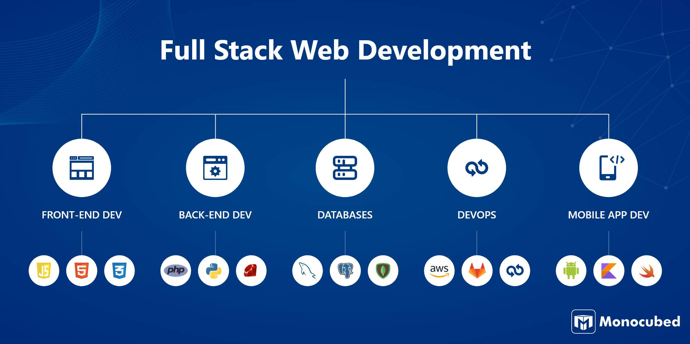

**Project Report**

**Front-End: HTML,CSS,JS**

**Backend: Django**

**Home Page:**

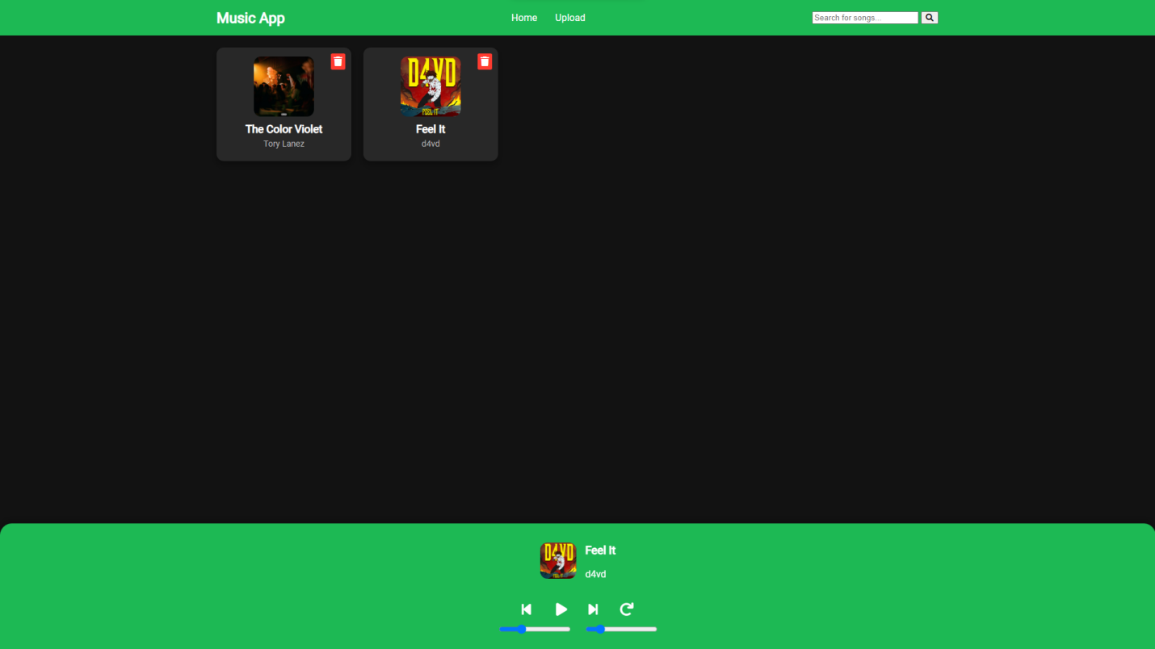

**Upload Page:**

